Genetic Quiz Series
A Case A Week, A Day, or an Hour!

Authorship:

Amy Lewanda, MD
Parith Wongkittichote, MD PhD
Debra Regier, MD PhD

Genetic Quiz – Week 1

A 7 year-old girl is brought to your office, accompanied by her mother and identical twin sister, for evaluation of a small, soft lump on her leg. It has been present for many months, but never caused a problem until the child injured it playing in the schoolyard. Physical examination revealed small, flesh colored soft prominence on the lateral aspect of the right knee, and 3 similar lesions on the patient back. There were multiple round bordered, hyperpigmented spots over the trunk and legs. Eight of these measured over 0.5 cm in their greatest dimension. Freckling was noted in the axilla, and there was mild scoliosis.

[picture from http://clinicalgate.com/neurocutaneous-syndromes/]

- What is syndromic diagnosis?

- The child’s parents are examined and found to be unaffected. Who else should be examines and why?

- What other medical specialist (besides geneticist!) should evaluate this child?

Bonus: At what 2 specific points in this girl’s life might the features be expected to worsen?

Answer to Genetic Quiz - Week 1

- The combination of axillary/inguinal freckling, cafe au lait spots, and soft growths (neurofibromas) is consistent with a diagnosis of neurofibromatosis type 1 (NF-1). The actual NIH criteria for diagnosis is 2 of the following 7 items:
  - Six or more café-au-lait macules over 5 mm in greatest diameter in prepubertal individuals and over 15 mm in greatest diameter in postpubertal individuals
  - Two or more neurofibromas of any type or one plexiform neurofibroma
  - Freckling in the axillary or inguinal regions
  - Optic glioma
  - Two or more Lisch nodules (iris hamartomas) on ophthalmologic exam
  - A distinctive osseous lesion (sphenoid dysplasia or tibial pseudarthrosis)
  - A first-degree relative with NF1 as defined by the above criteria

Lisch Nodules
[picture from http://clinicalgate.com/neurocutaneous-syndromes/]

- The twin sister should be examined even if the parents are found to be unaffected. That is because approximately 50% of patients with NF-1 are new mutations, and the mutation may have occurred prior to the separation of the twins, implying that they could possibly both be affected.

- An ophthalmologist should evaluate the patient to assess for the presence of Lisch nodules, as well as visual changes suspicious for an optic glioma

Bonus: The two times of greatest concern for growth of neurofibromas, progression of scoliosis, etc is during puberty/adolescence and pregnancy.

Reference: JM Friedman. Neurofibromatosis 1. in Pagon RA, Adam MP, Ardinger HH, et al., editors. GeneReviews® [Internet]. Seattle (WA): University of Washington, Seattle; 1993-2017.
Genetic Quiz – Week 2

You are called to attend the C-section delivery of an LGA infant with omphalocele. The baby weighed 4,800 gm. On physical exam, the baby is noted to have a glabellar hemangioma, large tongue, and the previously mentioned abdominal abnormality.

[picture from http://www.humpath.com/spip.php?article824]

- What is most likely diagnosis?

- What metabolic abnormality is most likely in the newborn period?

- What imaging study is indicated and why?

- The child is also found to have hemihypertrophy. Why is this significant?

Answer to Genetic Quiz - Week 2

- The most likely diagnosis is Beckwith-Wiedemann syndrome.

- The most frequent metabolic abnormality in these patients is neonatal hypoglycemia. Other reported abnormalities include polycythemia, hypocalcemia, and hyperlipidemia.

- An abdominal ultrasound is indicated in these patients at diagnosis every three months until age eight years due to the risk of malignancy. The most common malignancies are nephroblastoma, adrenal cortical carcinoma, hepatoblastoma, and neuroblastoma.

- The significance of hemihypertrophy is that it increases the risk for malignancy.

Reference: C Shuman, JB Beckwith, R Weksberg. Beckwith-Wiedemann Syndrome. in Pagon RA, Adam MP, Ardinger HH, et al., editors. GeneReviews® [Internet]. Seattle (WA): University of Washington, Seattle; 1993-2017.
Genetic Quiz – Week 3

A young child is brought to your office for a checkup, and the mother expresses concern that the baby is “too short”. The physical exam reveals a pleasant, alert baby with proximal shortening (rhizomelia) of the arms and legs. In addition, there is macrocephaly, frontal bossing, and a low nasal bridge. The elbows cannot be fully extended and the fingers are short and form a “trident” pattern when they are extended. There is suggestion of an early lordosis.

[Picture from http://www.thelancet.com/cms/attachment/2000989865/2003646180/gr4_lrg.jpg]

- What is the diagnosis?

- What gene is involved?

- What is this child’s risk of passing the disorder on to his children in the future?

Bonus: As a keen clinician, you order a CT scan to measure the size of the foramen magnum. Why?

Answer to Genetic Quiz - Week 3

- The correct diagnosis is achondroplasia. This is a common form of dwarfism, occurring in approximately 1:26,000-1:28,000 live births.

- The causative gene is FGFR3 (Fibroblast Growth Factor Receptor 3) located at chromosome 4p16. Other phenotypes associated with pathogenic variants in FGFR3 are
  - Hypochondroplasia
  - FGFR-related craniosynostosis
  - Thanatophoric dysplasia (types I and II), usually lethal in the perinatal period
  - SADDAN (severe achondroplasia with developmental delay and acanthosis nigricans) dysplasia

- This is an autosomal dominant condition, so the risk of an affected individual to pass disorder on is 1/2 or 50%. Both males and females are normally fertile, although affected women often requires a c-section to deliver the baby due to pelvic/bony considerations.

Bonus: In achondroplasia, the foramen magnum may be too small, increasing the risk for obstructive hydrocephalus and neurologic compromise.

Reference: RM Pauli. Achondroplasia. in Pagon RA, Adam MP, Ardinger HH, et al., editors. GeneReviews® [Internet]. Seattle (WA): University of Washington, Seattle; 1993-2017.
Genetic Quiz – Week 4

A 15 year-old male comes to your office for a routine checkup. He is in good health, but his mother expresses some concern over his development. On physical exam, he is slender, and his height is at the 90th percentile. There is a “eunuchoid” distribution of fat, with an increase in adipose tissue over the hips. He has no facial hair, and pubic has is Tanner II. The testicles are small, but descend bilaterally. There is mild gynecomastia. He attends a regular class, but does seem to have more academic difficulties than his friends or siblings.

[picture from http://marli-soares.zip.net/images/sindrome-de-klinefelter-5.jpg]

- What is your suspected diagnosis?

- What single blood test would you request? and what is the expected result?

- Are there any potential treatments to offer to the patient?

Answer to Genetic Quiz - Week 4

- The correct diagnosis is Klinefelter Syndrome.

- The only blood test which can accurately diagnose this condition is a chromosome analysis or karyotype. The karyotype result is 46 chromosomes with extra chromosome X (47,XXY). This is an example of aneuploidy (total chromosome count that is not even in multiple of the haploid number 23).

- Good results can be obtained with replacement testosterone therapy, either in injectable, transdermal or oral form. The supplement testosterone can prompt voice change, hair and genital growth, and a redirection of fat distribution away from a more typical female pattern.

Reference: J Visootsak, JM Graham. Klinefelter syndrome and other sex chromosomal aneuploidies. Orphanet J Rare Dis. 2006; 1: 42.

Genetic Quiz – Week 5

A 3-month old female is referred to your practice. She has a history of an interrupted aortic arch, repaired at 1 week of age. NICU course was complicated with hypocalcemia and poor feeding. Physical exam shows vigorous infant with squared nasal root, small posterior cleft of the secondary palate, long slender digits and a strawberry hemangioma on the left thigh. Routine chromosome analysis was done with normal results.

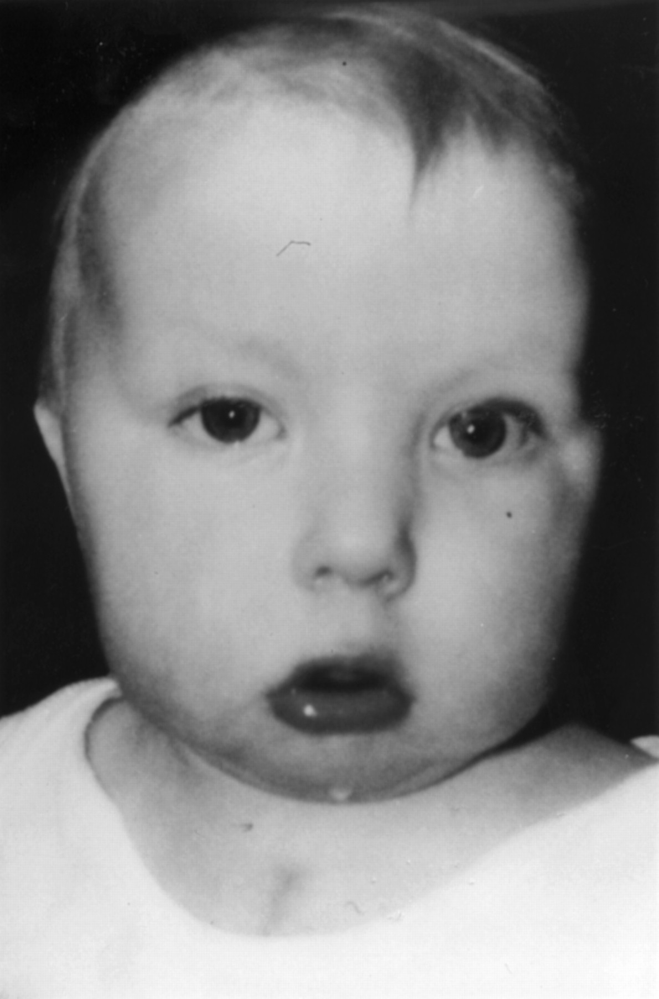
[picture from http://diseasespictures.com/wp-content/uploads/2012/09/Digeorge-Syndrome-7.jpg]

- What is the most likely diagnosis?

- What additional study would you request to confirm your suspicion?

- What other finding might you check from the chest x-ray (or by asking her cardiac surgeon) that would be consistent with this symptom?

Answer to Genetic Quiz - Week 5

- These features and history are consistent with the spectrum of chromosome 22q11 deletion syndromes. Names for these conditions include Velocardiofacial or VCF syndrome, Shprintzen syndrome, DiGeorge syndrome. There are mild distinctions between them, as the DiGeorge syndrome is more likely associated with hypocalcemia, and VCF/Shprintzen syndrome more likely to have a palatal cleft. There can be considerable overlap between these conditions due to a contiguous gene effect.

- These disorders are caused by microdeletions in the chromosome 22q11 region, often too small to be seen by karyotype analysis (even with a high resolution study). The best test to order would be a FISH (Fluorescent in situ Hybridization) study looking for the specific chromosome deletion which can pick up approximately 95% of the cases.

- Although a variety of additional cardiac malformations would be consistent with this condition, additional information would be obtained if a distinct anomaly (specifically hypoplastic or absent of thymus) were identified on X-ray or at the time of surgery.

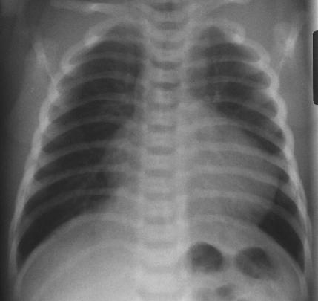
Absent of Thymus on X-ray
[picture from https://www.hawaii.edu/medicine/pediatrics/pemxray/v2c02.html]

Reference: DM McDonald-McGinn, BS Emanuel, EH Zackai, 22q11.2 Deletion Syndrome. in Pagon RA, Adam MP, Ardinger HH, et al., editors. GeneReviews® [Internet]. Seattle (WA): University of Washington, Seattle; 1993-2017.
Genetic Quiz – Week 6

On examining a young patient, you note the congenital anomaly depicted below.

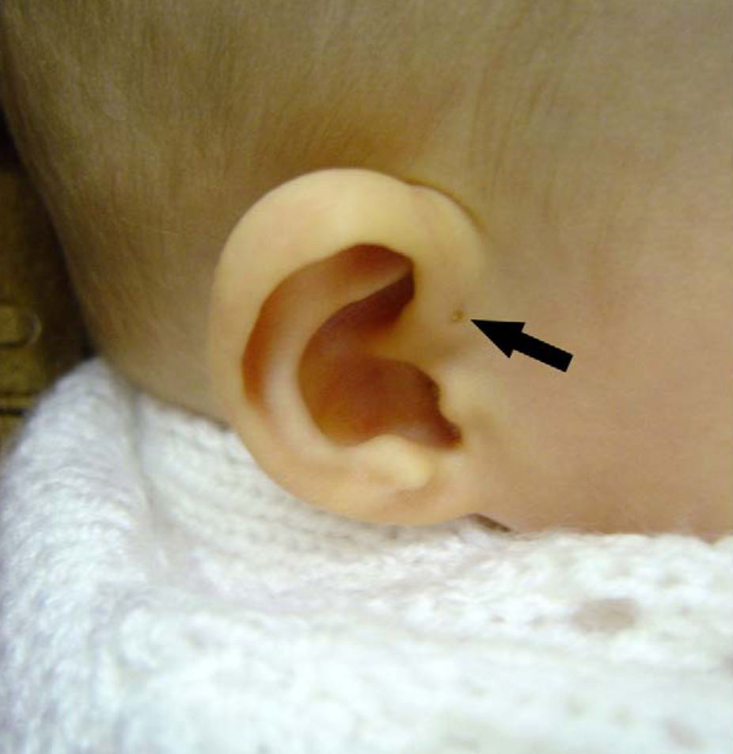
[Picture from T Tan, et al. Int J Pediatr Otorhinolaryngol. 2005 Nov;69(11):1469-74.]

- What is the name of the finding?

- Name one genetic syndrome of which this feature is a part.

- What two clinical (not lab) studies would you request on this patient and why?

Answer to Genetic Quiz – Week 6

- The structure indicated is a preauricular (ear) pit.

- Although generally benign finding, preauricular pits may be seen in a number of genetic syndromes including:
  - Branchio-oto-facial syndrome
  - Branchio-oto-renal (BOR) syndrome, also called Melnick-Fraser syndrome
  - Carpenter syndrome
  - Cat-eye syndrome
  - Kabuki make-up syndrome
  - Peters-Plus syndrome

- The two recommended tests would be:
  - Hearing test: external ear abnormalities may be seen in conjunction with internal ear abnormalities and hearing loss.
  - Renal sonogram: development of the ears and the kidneys occur simultaneously during gestation, and those with external ear anomalies are at a statistically increased risk of having concomitant renal anomalies.

Reference: T Tan, H Constantinides, TE Mitchell. The preauricular sinus: A review of its aetiology, clinical presentation and management. Int J Pediatr Otorhinolaryngol. 2005 Nov;69(11):1469-74.
Genetic Quiz – Week 7

These individuals all share the same genetic diagnosis.

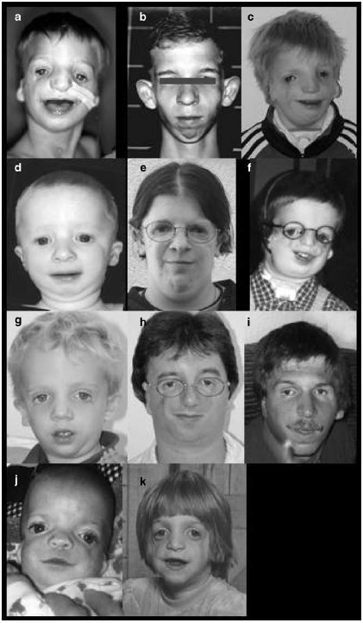
[Pictures from https://www.ncbi.nlm.nih.gov/books/NBK1532/ (left) https://www.researchgate.net/profile/Omri_Emodi2/publication/268875917/figure/fig1/AS:305420771053571@1449829394847/Fig-1-Patient-before-treatment-with-external-distraction-device-A-and-B-Five-year-old.png' (right)]

- What is the name of the syndrome?

- How is it inherited?

- In a severely affected infant, what is the greatest risk in the newborn period?

Bonus: The gene(s) for this condition has (have) been found. Please name the disease causing gene(s)?

Answer to Genetic Quiz – Week 7

- The condition is Treacher Collins syndrome - by the way, it is not a hyphenated name, as Treacher Collins is actually the individual who described it. It is also known as Franchesetti-Klein syndrome (which is hyphenated, as it was also described by these two separate people) and mandibulofacial dysostosis.

- In most cases, this syndrome is inherited in an autosomal dominant fashion; however inheritance pattern in small portion of the cases is autosomal recessive.

- The most severe complication in the newborn period is airway compromise due to significant micrognathia, which may require a tracheostomy.

Bonus: There are three genes responsible for Treacher Collins syndrome, which are TCOF1 responsible for 71%-93% of the cases, POLR1D and POLR1C, which together responsible for 8% of TCOF1-negative cases. Note that Treacher Collins syndrome caused by POLR1C mutation is inherited in an autosomal recessive manner.

Reference: SH Katsanis, EW Jabs. Treacher Collins Syndrome. in Pagon RA, Adam MP, Ardinger HH, et al., editors. GeneReviews® [Internet]. Seattle (WA): University of Washington, Seattle; 1993-2017.
Genetic Quiz – Week 8

Three sets of couples come to see you for genetic counseling.

- The first set are both concerned about the recurrence of pyloric stenosis in the family. In the first couple, the wife had pyloric stenosis as a baby. In the second couple, the husband had pyloric stenosis. Which couple is at a higher risk for recurrence of pyloric stenosis in their children? Why?

- The next set are concerned about clefting of the lip and palate. Couple A is of African-American heritage, Couple B is Asian. Both have negative family history of oral clefting. Which couple is at a higher a priori risk for cleating in their children.

- The last set come due to a parental history of paternal postaxial polydactyly. The first couple is African-American, the second couple is Caucasian. In which couple is the polydactyly more likely to a benign inherited variation?

Answer to Genetic Quiz – Week 8

- Pyloric stenosis is inherited as a multifactorial trait. This implies that expression of this trait depends on the additive effect or interaction of one or more genetic loci plus a number of external factors. The sum of those factors determines the individual’s liability of expressing the condition. This liability is normally distributed in the general population, and only those beyond a certain threshold will be affected. Since females are the sex less commonly affected with pyloric stenosis, the woman’s sum of liability in order to express that trait must be particularly high. In fact, the risk for the mother to pass on pyloric stenosis is 7-19%, depending on the sex of child; risk for an affected father is approximately 3-6%. So, the couple in which the wife is affected is at greater recurrence risk. Other factors increase the risk for passing on multifactorial traits include close relationship to the proband, more severe phenotype (i.e., bilateral vs unilateral cleft lip), and having multiple affected family members.

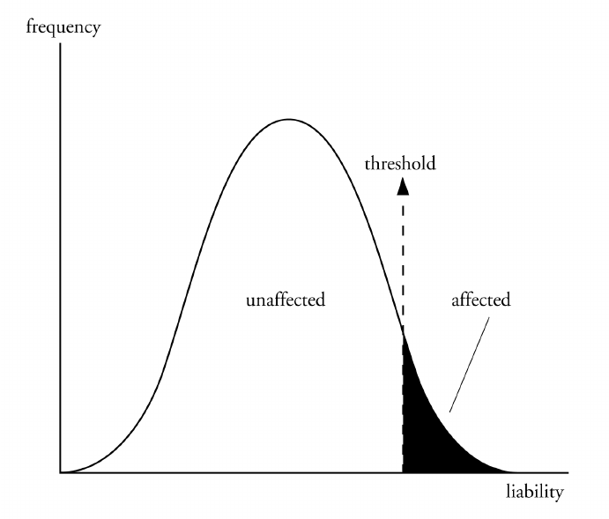

- There are clear racial/ethnic variations in the rates of oral cleating. It is most common in Native Americans (3.6/1,000 births), followed by Japanese (2.1/1,000), Chinese (1.7/1,000), Caucasian (1/1,000), and is least common in African Americans (0.3/1,000). The Asian couple is at higher risk in this scenario.

- Benign postaxial polydactyly is considerably more common in the African-American population.

Genetic Quiz – Week 9

A four-month old female infant is brought to your office for evaluation. The child has multiple joint contractors and the parents are planning on suing the obstetrician for malpractice. They ask if you could testify as to the negligence of the OB during the delivery, causing this child’s joint problems.

On physical exam, you note that the infant has involvement of all extremities. The upper extremities are internally rotated, elbows are extended, and the hand is in a “policeman tip” position (kind of like Fred Flintstone at rest). The shoulders are somewhat narrow, with decreased muscle mass. The knees are flexed, but the hips are quite stiff and may be dislocated. Both feet are clubbed.

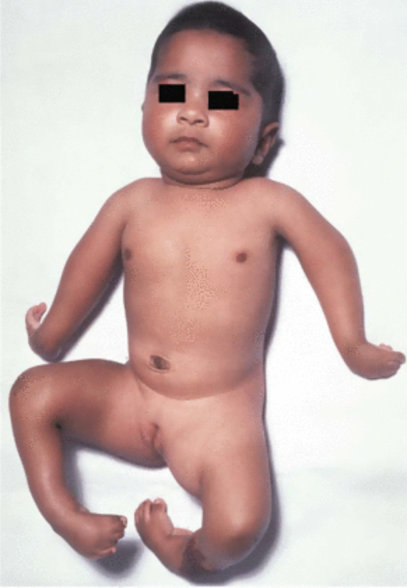
[Picture from JA Fixsen. Arthrogryposis multiplex congenita. in M Benson, JA Fixsen, M Macnicol, K Parsch. Children's Orthopaedics and Fractures (2009).]

- You wisely decline the parent’s invitation to testify, because you know that the child has a genetic disorder. What is its name?

- What is the inheritance?

- How could future pregnancies of this couple be evaluated to determine if there is another affected child?

Answer to Genetic Quiz – Week 9

- This condition is Amyoplasia, the most common form of Arthrogryposis Multiplex Congenita (AMC). AMC is a congenital abnormality of non-progressive multiple joint contractures. In Amyoplasia, both upper and lower extremities are usually involved. There are no associated internal organ malformations; however 10% of individuals with Amyoplasia have abdominal abnormalities, such as, gastrochisis, intestinal atresia. Some frequent minor features include glabellar or mid face capillary hemangiomas, micrognathia, and the decreased creases over joints from lack of movement.

- Inheritance is sporadic. There are many possible causes of AMC. It may occur as part of certain single-gene disorder, which can be inherited as autosomal dominant, autosomal recessive or X-linked pattern, or chromosomal abnormalities. It may occur because of abnormalities in nervous or musculoskeletal systems. Environmental factors also cause AMC.

- Ultrasound studies, especially those using real time images to assess fetal movement are the best way to prenatally diagnosis the condition at the present time.

Reference: Hall JG. Arthrogryposis Multiplex Congenita. National Organization for Rare Disorders. February 2013; https://rarediseases.org/rare-diseases/arthrogryposis-multiplex-congenita/.

Genetic Quiz – Week 10

You are asked to evaluate an 8 year-old child for some unusual features. Her mother’s pregnancy history is unremarkable, and she was born full term at 7 lbs, 9 oz. Complications in the newborn period included the diagnosis of an imperforate anus with rectovaginal fistula, surgically repaired at 6 months of age. Her only other significant past medical history is sensorineural hearing loss. Physical exam is remarkable for a “lop” ear and thumb anomalies (pictured below).

[Picture from FJ Lin, W Lu, D Gale, et al. Exp Ther Med. 2016 Apr; 11(4): 1249–1252.]

- What is the diagnosis?

- How is it inherited?

- Name 2 other syndromes/conditions that are in the differential diagnosis of an individual with an imperforate anus.

Answer to Genetic Quiz – Week 10

- The correct diagnosis is the Townes-Brocks syndrome. This is generally recognized as a trio thumb anomalies, ear anomalies, and imperforate anus. Renal defects are also common.

- The inheritance is autosomal dominant, with a high variability of expression.

- There are many syndromes which include imperforate anus, including:
  - VACTERL
  - Cat-Eye syndrome
  - Townes-Brocks syndrome
  - Baller-Gerold syndrome
  - Extrophy of cloaca sequence
  - FG syndrome
  - Pallister Hall syndrome
  - Johanson-Blizzard syndrome
  - Short rib polydactyly syndrome type 1
Less commonly as a part of: DiGeorge syndrome, Meckel-Gruber syndrome, Thanotophoric dysplasia, Trisomy 18 and Walker-Warburg syndromes.

Reference: J Kohlhase. Townes-Brocks Syndrome. in Pagon RA, Adam MP, Ardinger HH, et al., editors. GeneReviews® [Internet]. Seattle (WA): University of Washington, Seattle; 1993-2017.

Genetic Quiz – Week 11

You are evaluating a baby with cleft lip and palate in your office. The parents have many questions regarding how this happened and if it will happen again in the future pregnancies. You examine the baby and find no other abnormalities to suggest a syndromic diagnosis.

- What other 2 pieces of information would be needed to help you determine a recurrence risk for this family?

- Assuming that this information is negative, what is the empiric recurrence risk range for isolated cleft lip/palate?

- At what stage of gestation does lip/palate develop?

Bonus: What if, on physical exam of the baby, you noted two pit-likes depressions in the lower lips — how would this change the recurrence risk for the baby?

Answer to Genetic Quiz – Week 11

- In order to evaluate the recurrence risk, one needs to consider the family history (including examining the parents’ lip/palate for a mild form of cleft), and the prenatal history (to exclude teratogens such as antiepileptic medications as a potential cause of clefting). Since oral cleating is inherited in a multifactorial manner, there are also factors which help to further refine the risk, such as severity of the cleft.

- The empiric recurrence risk for isolated cleft lip/palate is 3-5%.

- Palatal development occurs between weeks 6 and 12; lip development at around the 5th through 9th weeks.

Bonus: The presence of oral cleating with lip pits is pathognomonic for the van der Woude syndrome, which is an autosomal dominant disorder and has a 50% recurrence risk. (pictured below)

van der Woude syndrome
[Picture from http://img.medscapestatic.com/pi/meds/ckb/52/44152tn.jpg]

Genetic Quiz – Week 12

These individuals pictured below have the same condition.

[Picture from (left) https://emmakissock.wordpress.com/2010/05/07/saturday-is-cornelia-de-lange-syndrome-awareness-day%E2%80%8F/ (right) http://www.medicalzone.net/pediatric-definition---cornelia-de-lange.html]

- What is the diagnosis?

- Besides typical facial features and hirsutism, what other major feature would you expect on the physical exam?

- What is the prognosis of the child’s intellect?

- There are many genes associated with this condition. What is the most common disease causing gene?

Bonus: One chromosomal region has been implicated in producing many similar physical features. Where is it?

Answer to Genetic Quiz – Week 12

- The correct diagnosis is the Cornelia de Lange syndrome, also called Brachmann-de Lange syndrome or de Lange syndrome.

- The majority of finding on exam is limb reduction or defect, but other significant findings are microcephaly and growth retardation.

- The prognosis is poor, with severe mental retardation and behavior problems.

- Approximately 60% of the cases have mutation in NIPBL gene. Other genes that are found to be associated with this syndrome are SMC1A (~5%), HDAC8 (~4%), SMC3 (1%-2%) and RAD21 (<1%).

Bonus: Individual with abnormalities of the 3q26 region have shown similar phenotypic features as affected patients.

Reference: MA Deardorff, SE Noon, ID Krantz. Cornelia de Lange Syndrome. in Pagon RA, Adam MP, Ardinger HH, et al., editors. GeneReviews® [Internet]. Seattle (WA): University of Washington, Seattle; 1993-2017.

Genetic Quiz – Week 13

A young boy is being seen at the cardiologist in follow up for his ASD. On physical exam, he is short statured, with short limbs. The fingernails are very hypoplastic, and you notice that each hand has 6! the postaxial polydactyly involves only his hands. He is 2 years old, but does not have a full set of teeth; some are missing, and some of the ones which are present appear small.

[Picture from R Ananthakrishna, AV Kulkarni. Austin J Clin Case Rep. 2014;1(5): 1025.]

- What is the correct diagnosis?

- How is it inherited?

Bonus: In what population were the largest kindred of affected individuals detected?
Answer to Genetic Quiz – Week 13

- The combination of short stature, polydactyly, ASD, tooth and nail hypoplasia is classic for Ellis-van Creveld syndrome, also called chondroectodermal dysplasia or mesoectodermal dysplasia.

- This is an autosomal recessive condition. It is caused by mutation in EVC1 and EVC2, which are located at chromosome 4p16.1.

Bonus: The largest kindred with this condition were an Amish population.

Reference: G Baujat, M Le Merrer. Ellis-van Creveld syndrome. Orphanet J Rare Dis. 2007; 2: 27.

Genetic Quiz – Week 14

The patient pictured below has been referred to you due to dermatologic abnormalities. His skin is covered by innumerable dark spots as pictured. The spots were not present at birth, but began developing within the first few months of life.

Physical exam reveals a small male (height at the 10th percentile), with several features of note. The face is somewhat triangular, and the ears are prominent. There is hypospadias present, and he had surgery as a younger child for unilateral cryptorchidism. His speech is somewhat difficult to understand and there appears to be a hearing deficit.
[Picture from http://www.scielo.br/scielo.php?script=sci_arttext&pid=S0365-05962017000100127]

- What is the most likely diagnosis?

- What test should be performed to rule out a problem commonly associated with this condition?

- What is the inheritance?

Answer to Genetic Quiz – Week 14

- The diagnosis is Noonan Syndrome with Multiple Lentigines (NSML), so called Multiple Lentigines Syndrome or LEOPARD syndrome. LEOPARD is an acronym for
Lentigines
EKG abnormalities
Ocular hypertelorism
Pulmonic stenosis
Abnormal of genitalia
Retardation of growth
Deafness

- An EKG should be performed to look for abnormalities. Approximately 85% of affected individuals have cardiovascular abnormalities which hypertrophic cardiomyopathy is the most common (up to 70%). Others possible defects are pulmonic stenosis (~25%) and conduction defects (23%).

- This condition is autosomal dominant.

Reference: BD Gelb, M Tartaglia. Noonan Syndrome with Multiple Lentigines. in Pagon RA, Adam MP, Ardinger HH, et al., editors. GeneReviews® [Internet]. Seattle (WA): University of Washington, Seattle; 1993-2017.

Genetic Quiz – Week 15

A 36 years old, mildly retarded blonde woman is seen in clinic. She has a diagnosis of PKU, which is untreated. She is married to a man with two normal genes for this condition, and is now 8 weeks pregnant.

- What will be the PKU status of the baby? (affected, carrier, unaffected)

- What are the two main risks for the baby as the infant if a mother with PKU?

- Is dietary treatment needed for the mother in this instance? Why or why not?

- Which infant is at higher risk for congenital problems - the unaffected child of PKU mother, or the affected child of carrier parents?

Answer to Genetic Quiz – Week 15

- The child will be an obligate carrier, as he or she will inherit one of the mother’s affected alleles.

- The two main risks for a child of a mother with untreated PKU are microcephaly/MR and congenital heart disease.

- Yes, even though the child will be an unaffected carrier for PKU, development in a millieu of high phenylalanine (because the mother is unable ti metabolize Phe normally) puts the child at risk for congenital defects. The mother should be placed on a low phenylalanine diet.

- The child of an untreated mother with PKU is at greater risk. A fetus with PKU is not affected prenatally, as the mother is able to metabolize the phenylalanine adequately to prevent a dangerously high blood level.

Reference: Committee on Genetics. Maternal Phenylketonuria. Pediatrics. Aug 2008, 122 (2) 445-449

Genetic Quiz – Week 16

The individuals below all have variations of the same condition.

[Picture from https://chromosomaldisorder.wikispaces.com/Holoprosencephaly]

- What is the diagnosis?

- With what chromosomal abnormality is it most commonly associated?

Bonus: What is the name of the gene, located at 7q36, which is the first such gene implicated in both human and mouse forms if this condition?

Answer to Genetic Quiz – Week 16

- The correct diagnosis is holoprosencephaly. This is a malformation sequence in which the embryonic forebrain fails to cleave normally into right and left halves. There is a range of severity and cases classified as alobar, semilobar, lobar, middle interhemispheric and septopreoptic. Remember the phrase “The face predicts the brain”. In an individual with striking midline deficiency of the face (midline cleft palate, hypotelorism or cyclopia - one eye), it is highly likely that there is also an underlying midline defect of the brain.

- Although there are many, many chromosomal abnormalities that may be associated with holoprosencephaly, by far the most common is trisomy 13.

Bonus: The name given to the first gene implicated to both human and mouse forms of holoprosencephaly is Sonic Hedgehog (SHH).

Who says geneticists aren’t fun?!!

Reference: BD Solomon, A Gropman, M Muenke. Holoprosencephaly Overview. in Pagon RA, Adam MP, Ardinger HH, et al., editors. GeneReviews® [Internet]. Seattle (WA): University of Washington, Seattle; 1993-2017.

Genetic Quiz – Week 17

The patient below is brought in for evaluation. He is very strikingly growth retarded (prenatal onset), with birth weights at full term of 1,600 grams. Physical exam is also remarkable for severe microcephaly, and a prominent nose. He is mentally retarded.

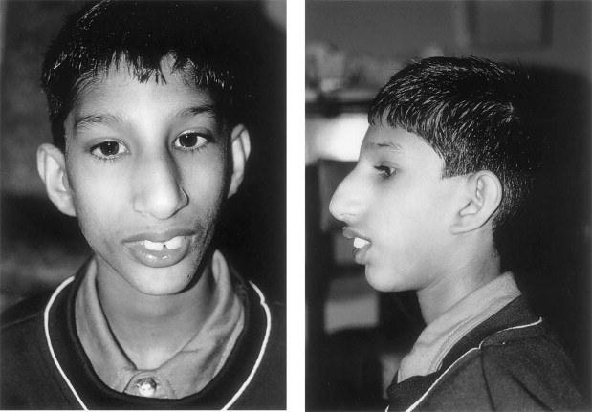
[Picture J Goodship, H Gill, J Carter, et al. Am J Hum Genet. 2000 Aug;67(2):498-503]

- What is the diagnosis?

- What is the inheritance pattern?

Bonus: What is the former name (now considered pejorative) for this condition?

Answer to Genetic Quiz – Week 17

- The correct diagnosis is Seckel syndrome. This is a form of dwarfism in which there is very significant growth retardation, listed as an average of 7.1 SD below the mean! Microcephaly is severe, and about half develop craniosynostosis.

* Note that Seckel syndrome is previously distinguished from another syndrome named primary autosomal recessive microcephalies (MCPH) by height, but due to advance in molecular genetics, they were now recognized as variable phenotypes of Primary Autosomal Recessive Microcephalies and Seckel Syndrome Spectrum Disorders.

- The inheritance is autosomal recessive.

Bonus: The former term used to described these individuals is “Bird headed dwarf”.

Reference: A Verloes, S Drunat, P Gressens, S Passemard. Primary Autosomal Recessive Microcephalies and Seckel Syndrome Spectrum Disorders. in Pagon RA, Adam MP, Ardinger HH, et al., editors. GeneReviews® [Internet]. Seattle (WA): University of Washington, Seattle; 1993-2017.

Genetic Quiz – Week 18

An eight day old female is brought to the ER for weight loss, jaundice, and vomiting. She is nondysmorphic. Urine analysis show 2+ ketones and 3+ reducing substances. The baby is admitted, and workup reveals E. coli sepsis. The baby also noted to have early cataract formation bilaterally.

The child was full term, 3200 gms at birth. Pregnancy was uncomplicated, and family history is unremarkable. The baby has been feeding Enfamil 20 with Iron since birth?

- What is the most likely diagnosis?
- What is the enzyme defect in the classic form of this disorder?
- What two pieces of lab data can be used to confirm (if not diagnosed) your hunch?
- What type of the formula should the baby be given?

Answer to Genetic Quiz – Week 18

- The most likely diagnosis in a newborn infant with jaundice, weight loss, vomiting, reducing substances in the urine, cataracts, and E. coli sepsis is galactosemia.

- GALT (or galactose-1-phosphate uridyl transferase) is the main enzyme responsible; two other enzymes (galactokinase and UDP-galactose 4’ epimerase) also contribute to metabolism of galactose.

- Lab data that can be used to confirm are:
  - Identification of galactose as the reducing substance present in the urine.
Note: Clinistix (urine dipstick) will pick up glucose, but not galactose. Clinitest tablets are used to detect galactose – so a negative clinistix abd a positive clinitest is highly suggestive of galactosuria.
  - Information from the newborn state screening. Preliminary results from this screen may be helpful in raising suspicion of the disorder.
  - Blood levels of galactose-1-phosphate
  - Enzyme assay for GALT activity

- The baby suspected of having galactosemia should be placed on a soy based (lactose free) formula such as Isomil or Prosobee. Of note the fact that “Lactofree” formula is not totally free of the sugar, and is not recommended for these patients.

Reference: GT Berry. Classic Galactosemia and Clinical Variant Galactosemia. in Pagon RA, Adam MP, Ardinger HH, et al., editors. GeneReviews® [Internet]. Seattle (WA): University of Washington, Seattle; 1993-2017.

Genetic Quiz – Week 19

See the photos of the individuals below:

[Picture from (left) http://escholarship.org/uc/item/0r5371ck,
(middle) http://mohammadamir.blogspot.com/2011/10/hetrochromia-iridis.html,
(right) http://emedicine.medscape.com/article/950277-overview]

- What is the correct diagnosis?

- What is the inheritance pattern?

- What is the associated sensory deficit?

- A typical feature in this condition is widely spaced medial acanthi with normal interpupillary distance. What is the specific term that describes this finding?

Answer to Genetic Quiz – Week 19

- The correct diagnosis is the Waardenburg syndrome.

- The inheritance pattern in most cases of Waardenburg syndrome is autosomal dominant. In some types of Waardenburg syndrome, the inheritance pattern is autosomal recessive.

- The associated sensory deficit is a sensorineural hearing loss.

- The term is dystopia canthorum (pictured below).

Dystopia canthorum
[Picture adapted from http://entokey.com/developmental-anomalies-of-the-lids/]

Reference: JM Milunsky. Waardenburg Syndrome Type I. in Pagon RA, Adam MP, Ardinger HH, et al., editors. GeneReviews® [Internet]. Seattle (WA): University of Washington, Seattle; 1993-2017.

Look! Who says genetic patients can’t be cool!

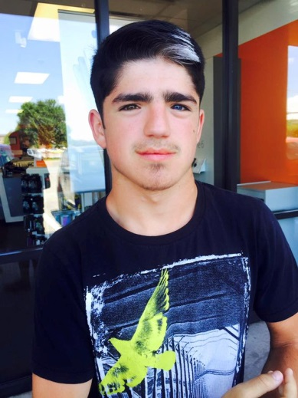
[Picture from https://pbs.twimg.com/media/CaK73WpWAAAuVjV.jpg]

Genetic Quiz – Week 20

You are asked to evaluate a newborn female for apparent dwarfism. You note the child to have flat facial features, sort limbs, bowed tibia with prominent skin dimples over the tibiae. The mother tells you that an amniocentesis was done due to the fact that she is 37 years old, and the results were 46, XY!

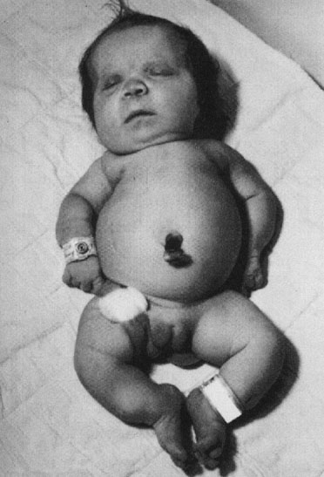

- What is the most likely diagnosis?

- How is the karyotype explained?

- What is the prognosis?

Answer to Genetic Quiz – Week 20

- This condition is campomelic dysplasia.

- The causative gene for this condition is SOX9, which is a sex determining region of Y (SRY) related gene on chromosome 17. Defects in this gene cause both campomelic dysplasia and sex reversal (approximately 75% of cases).

- The prognosis is very poor - approximately 90% of cases die in early infancy from respiratory insufficiency caused by airway instability (tracheobronchomalacia) or cervical spine instability.

Reference: S Unger, G Scherer, A Superti-Furga. Campomelic Dysplasia. in Pagon RA, Adam MP, Ardinger HH, et al., editors. GeneReviews® [Internet]. Seattle (WA): University of Washington, Seattle; 1993-2017.

Genetic Quiz – Week 21

A husband and wife come in together for genetic counseling. They both have a skeletal dysplasia, which you immediately recognize as achondroplasia. The wife is 17 weeks pregnant.

- What are their chances of having a normal statured child?

- What are their chances of having achondroplastic child?

- Sonogram of the fetus shows very dramatically reduced limb lengths, relatively large head. The findings are more severe than in either parent. What is the explanation?

- What is the prognosis for the fetus?

Answer to Genetic Quiz – Week 21

- The chance of two achondroplastic parents to have a normal statured child is 1 in 4 or 25%. Each parent is heterozygous for the mutation which causes achondroplasia. (Aa - with the A being the achondroplasia allele, and a being normal).

 | A | a
A | AA - lethal | Aa - achondroplasia
a | Aa - achondroplasia | aa - normal statured

- The chance of having a child with achondroplasia is 2 in 4 or 50%.

- This is what would be expected in the double dominant form - the child having inherited altered gene from both parents.

- Prognosis is very poor - it is considered a lethal form, with affected infants generally dying in the newborn period from respiratory compromise.

Reference: RM Pauli. Achondroplasia. in Pagon RA, Adam MP, Ardinger HH, et al., editors. GeneReviews® [Internet]. Seattle (WA): University of Washington, Seattle; 1993-2017.
Genetic Quiz – Week 22

A newborn infant of a 23 years old mother is noted to have multiple dysmorphic features. She has a midline cleft lip and cleft palate, hypotelorism, postaxial polydactyly and scalp defects (cutis aplasia). Her hands are clenched and thumbs are overlapping the palm bilaterally.

[Picture from https://pedclerk.bsd.uchicago.edu/page/trisomy-18-edwards-trisomy-13-patau]

- What is the most likely diagnosis?

- How could this have been definitively diagnosed during pregnancy?

- The mother is very upset and admits that she drank alcohol and smoked cigarettes during the pregnancy, and asks if this is the cause. What do you tell her?

Answer to Genetic Quiz – Week 22

- The most likely diagnosis is Trisomy 13.

- It can be detected during pregnancy by chorionic villus sampling, amniocentesis, or cordocentesis. Cell-free fetal DNA analysis from maternal peripheral blood, which is less invasive, is also a good screening test due to its high sensitivity (91.6%) and specificity (99.9%).

- As detrimental to a fetus as alcohol and cigarettes may be, it is not the cause of such chromosome defects. Specifically, the presence of the extra chromosome was present from the time of conception and was not influenced by anything that the mother did during pregnancy. She had no control over the chromosome compliment in the baby. (I usually explain that they had no more control over this than they do over eye color or hair color.)

Reference:
Trisomy 13 Syndrome. National Organization for Rare Disorders (NORD). 2007; http://rarediseases.org/rare-diseases/trisomy-13-syndrome/.
Committee Opinion No. 640: Cell-Free DNA Screening For Fetal Aneuploidy. Obstet Gynecol. 2015 Sep;126(3):e31-7.

Genetic Quiz – Week 23

Match the prenatal exposure to the physical risks to the newborn:

1. Accutane | A. Cleft palate, neural tube defects
2. Antiepileptic | B. Anotia, microtia
3. Hyperglycemia | C. Tooth staining
4. Tetracycline | D. LGA, heart defect, hypoglycemia
5. Methotrexate | E. IUGR, skull/limb anomalies, neural tube defects

Answer to Genetic Quiz – Week 23

- Accutane (13-cis-retinoic acid) or isotretinoin is a vitamin A derivative with tremendous teratogenic potential. Exposure has been associated with defects of CNS (including hydrocephalus, microcephaly and intellectual compromise), cardiac defects (conotruncal malformations), and most characteristically, bilateral anotia/microtia with stenosis of the external auditory canals (choice B).

- Antiepileptics (including phenytoin, carbamazepine, valproic acid, and phenobarbital) are folic acid antagonists, and increase the risk for cleft palate and neural tube defects in the fetus (choice A).

- Hyperglycemia (i.e., diabetic mother) increases the chance for the baby to be LGA, to have cardiac defects, and to experience hypoglycemia in the newborn period (choice D).

- Tetracycline is known to deposit in the fetal teeth and bones during pregnancy. In the early 1960’s, yellow-gold fluorescence was described in the mineralized structures of a fetal skeleton whose mother had taken the drug during pregnancy. Later reports documented bright yellow staining of the deciduous teeth due to prenatal fetal tetracycline exposure (choice C).

- Methotrexate is a folate antagonist. Fetuses exposed to methotrexate usually present with IUGR, failure to thrive, malformation of the CNS (hydrocephalus, neural tube defects), skull (delayed ossification, craniosynostosis), limbs (hypoplastic limbs and nail, ossification defects) and, in some cases, cardiac defects (choice E).

Reference: C Leroy, J Rigot, M Leroy, et al. Immunosuppressive drugs and fertility. Orphanet J Rare Dis. 2015; 10: 136.

Genetic Quiz – Week 24

A newborn female is noted to have marked edema of the hands and feet, decreased femoral pulses and a broad based neck. Pictures of patient feet and an older patient are below.

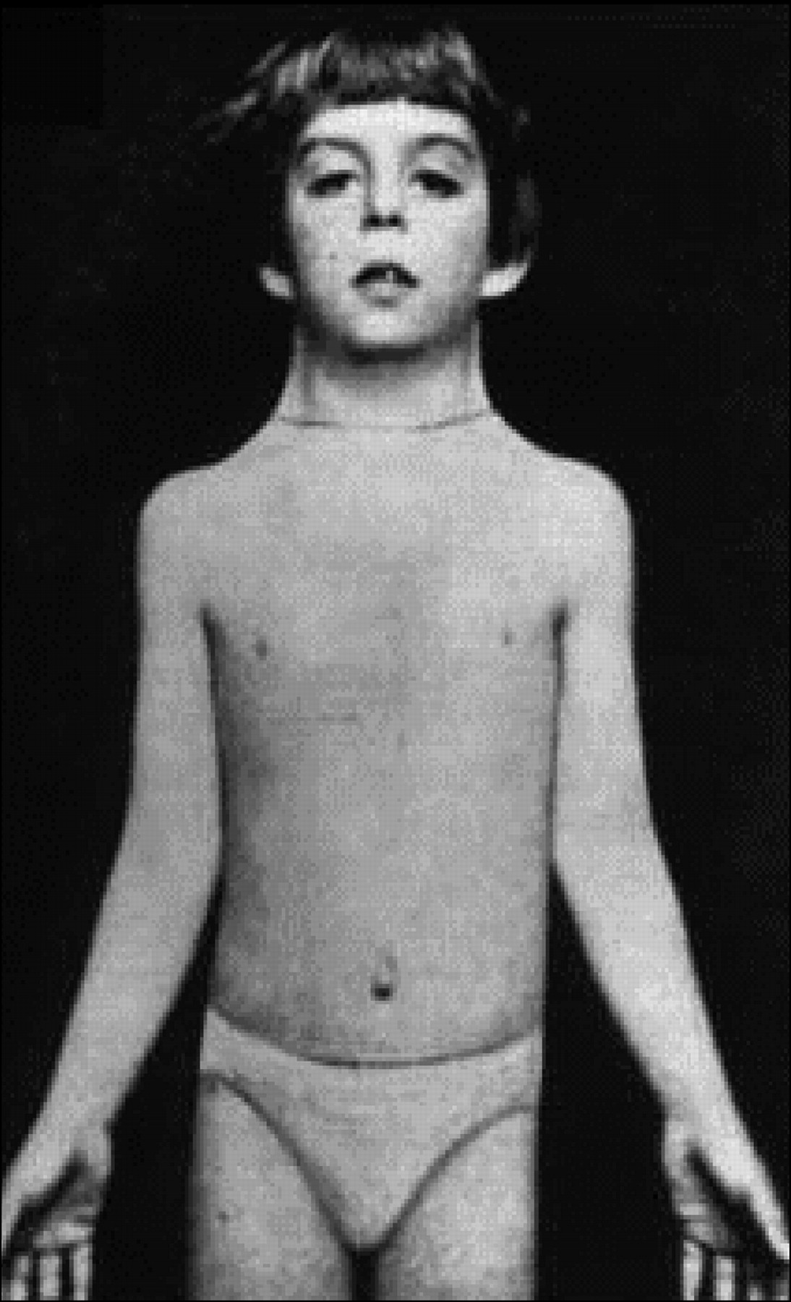
[Picture from (left) http://emedicine.medscape.com/article/949681-overview
(right) http://pedsinreview.aappublications.org/content/29/7/219]

- What is the most likely diagnosis?

- List 3 possible chromosome results that would be consistent with the diagnosis.

- What is the prognosis for intellectual development?

Answer to Genetic Quiz – Week 24

- The most likely diagnosis is Turner syndrome.

- Possible chromosome results are:
  - 45,X
  - 46,XX/45,X - mosaic
  - 46,XY/45,X - mosaic
  - 46,XX(r)X - ring chromosome with loss of material
  - 46,XX(i)Xq - isochromosome X
Possible chromosome arrangement in patients with Turner syndrome
[Picture from https://online.epocrates.com/data_dx/reg/1106/img/1106-2-iline.gif]

- The vast majority are of normal intelligence. May have specific learning difficulties due to problems with visual-spatial orientation, and difficulties with mathematics. Some problems with social interactions may exist due to physical differences between them and their peers, as well as poor physical coordination or clumsiness.

Reference: Turner Syndrome. National Organization for Rare Disorders (NORD). 2012; https://rarediseases.org/rare-diseases/turner-syndrome/

Genetic Quiz – Week 25

This patient was born with coronal craniosynostosis, and severe syndactyly of both hands and feet.

[Picture from A Akram, MM McKnight, H Bellardie. Br Dent J. 2015 Feb 16;218(3):129-41.]

- What is the diagnosis?

- What gene is responsible?

- What is the likelihood of the patient’s child being affected?

Answer to Genetic Quiz – Week 25

- The diagnosis is Apert syndrome. Although the facies may appear similar in many of the craniosynostoses, the digital abnormalities are essential in helping to differentiate them. For example, Apert syndrome has the classical “Mitten type” syndactyly, on both hands and feet. Crouzon syndrome is not generally associated with digital abnormalities. Pfeiffer syndrome has broad thumbs and great toes, and Jackson-Weiss syndrome has foot abnormalities with normal hands.

- Mutations in FGFR2 (Fibroblast Growth Factor Receptor 2) cause Apert syndrome.

- This is an autosomal dominant disorder, with a 50% chance for the patient’s child to be affected.

Reference: NH Robin, MJ Falk, CR Haldeman-Englert. FGFR-Related Craniosynostosis Syndromes. in Pagon RA, Adam MP, Ardinger HH, et al., editors. GeneReviews® [Internet]. Seattle (WA): University of Washington, Seattle; 1993-2017.

Genetic Quiz – Week 25

This individual was referred for evaluation of slender body habits with long arms and legs. Medical history is significant for mild mental retardation and two episodes of thrombophlebitis. Family history reveals that the parents are second cousins. On examination, the patient is wearing glasses and there is a downward subluxation of the lens in each eye. The joints are noted to be somewhat stiff. Scoliosis is noted.

[Picture from http://ars.els-cdn.com/content/image/3-s2.0-B9780123746023000420-gr14.jpg?httpAccept=%2A%2F%2A]

- What is the diagnosis?

- What test or tests are used to confirm the daignosis?

- What is the mode of inheritance?

Answer to Genetic Quiz – Week 25

- The diagnosis in this individual is homocystinuria. The disorder has many similar features to the Marfan syndrome, with some specific differences: lens typically dislocates downward instead of upward, joints are stiff instead of hyperflexible, there is an increased risk of thrombotic events, and the majority of patients show learning disabilities and/or mental retardation.

- The diagnosis is made on amino acid testing of the blood or fresh urine. An increased homocysteine level is diagnostic, and is accompanied in the blood by a high methionine and low cysteine level. The cyanide nitroprusside test is a screening tool, and not adequate for diagnosis. Enzyme activity of cystathione synthetase may be measured in liver biopsy or fibroblast culture, but most patients would prefer to do the blood and urine tests!

- As in the case with the majority of biochemical (enzymatic) defects this disorder is autosomal recessive.

Reference: JD Picker, HL Levy. Homocystinuria Caused by Cystathionine Beta-Synthase Deficiency. in Pagon RA, Adam MP, Ardinger HH, et al., editors. GeneReviews® [Internet]. Seattle (WA): University of Washington, Seattle; 1993-2017.

Genetic Quiz – Week 26

- What form of inheritance explains the following pedigree?

[Picture from http://cursoenarm.net/UPTODATE/contents/mobipreview.htm?27/7/27763]

- Name two disorders inherited in this manner?

Answer to Genetic Quiz – Week 26

- The pedigree shows maternal or mitochondrial inheritance (the disorder is generally passed to all offspring of an affected woman, but none of an affected man’s offspring). This is because the mitochondria (and therefore the mitochondrial DNA) are present in the egg cell, and none are transmitted via the sperm.

- Examples of disorders inherited by mitochondrial inheritance include:
  - Leber’s hereditary optic neuropathy
  - Kearns-Sayre syndrome
  - Mitochondrial myopathies such as MERRF (Myoclonic Epilepsy with Ragged Red Fibers) or MELAS (Mitochondrial Encephalomyopathy, Lactic Acidosis, and Stroke-like episodes)

Genetic Quiz – Week 27

You have been called to evaluate the child pictured below, and you suspected the child to have Down syndrome, Chromosomes are pending. You call the lab to see if there is a preliminary report, and the tech informs you that there are 46 chromosomes per cell, and no evidence of mosaicism.

- List 5 features notable on physical exam that would increase the likelihood of this diagnosis.

- What chromosome anomaly would you expect on the final report?

- In this form of Down syndrome, what other testing would be recommended for the family?

- What are the potential implications for the parent’s future children?

- What is this child’s risk of having congenital heart disease?

- What is the effect of maternal age on the incidence of this form of Down syndrome?

- What is the recurrence risk of Down syndrome in a family who has had a child with Trisomy 21?

Answer to Genetic Quiz – Week 27

- Features suggestive of Down syndrome in a newborn include: Hypotonia, Flat facial profile, Small or dysplastic ears, Poor Moro reflex, Upslanting palpebral fissures, Epicanthal folds, Brushfield spots, Short neck with excess nuchal skin, Brachydactyly (short fingers), Clinodactyly (incurving) of the fifth fingers, Single transverse palmar crease, Widened space between first and second toe
Note: protruding tongue is not a reliable feature

- This child is expected to have a form of translocation Down syndrome. In this situation, an additional chromosome 21 has become attached to another chromosome - in counting the number distinct chromosomes per cell, there are only 46, but one of those chromosomes has attached to it the additional material from #21 which produces the clinical phenotype. There may be a Robertsonian translocation (21:21), or the extra piece may be attached to another chromosome, most commonly 14 or 22.

An example of Down syndrome, translocation type
[Picture from CD Padilla, EM Cutiongco-de la Paz, MAD Chiong, GS Charcos, NS Cadag. Acta Med Philipp. 2009 Jan-Mar;43(1):12-15.]

- If this form is found, the parents should have karyotype testing to determine either one is a translocation carrier.

- If one parent is a translocation carrier, the recurrence risk may increase dramatically. For example, if one parent is found to have a 21:21 translocation (both 21st chromosome are attached to each other), the recurrence risk for liveborn children is almost 100%. This is because the affected parent can only produce gametes containing either 2 copies (which when involved in conception would produce Down syndrome) or 0 copies (nonviable embryo).

- The risk of congenital heart disease in translocation Down syndrome is the same as in Trisomy 21 - about 40-50%.

- The risk of translocation Down syndrome is not affected by maternal age as is trisomy 21, because the aging of the ovum is not a contributing factor. The risk of giving birth to a child with translocation Down syndrome would be the same fir a 20 year old or a 40 year old.

- The risk of recurrence in a family with a child with Trisomy 21 is generally quoted as 1% or the mother’s age related risk - whichever is greater.
Genetic Quiz – Week 28

A 6 year old male is brought in for evaluation for behavior problems and overeating. His mother recounts that the child weighed 6 lb 10 oz at birth, and was a poor feeder in infancy, undergoing a failure to thrive workup at 6 months. However, beginning around age 3, he had a marked increase in appetite, and accordingly weight gain. His behavior is problematic, and he takes food from other children at his daycare or even from family members at mealtimes. In addition, he likes to eat unusual foodstuffs, such as margarine sticks or spoons of mayonnaise.

Physical exam reveals an overweight, distractible male with almond shaped eyes and multiple scabs on the arms which the mother reports are due to skin picking.

[Picture from https://image.slidesharecdn.com/intellectualdisability-150415051941-conversion-gate01/95/intellectual-disability-29-638.jpg?cb=1429093273]

- What is the most likely diagnosis?

- A chromosome 15 deletion is identified on the patient’s chromosome test. Is the deletion more likely to be paternal or maternal?

- What unrelated genetic syndrome is caused by a deletion of the same genetic material from the other parent?

- What is a major concern when follow-up this patient?

Answer to Genetic Quiz – Week 28

- The most likely diagnosis is the Prader-Willi syndrome.

- The deletion of genetic material on chromosome 15q11-q13 is most often paternal.

- If the same genetic region was deleted on the maternal chromosome 15, the patient would be expected to show signs of Angelman syndrome.
Hint: Prader-Willi has the Paternal deletion. AngelMan syndrome has the Maternal deletion.

- A major concern of this patient is weight. Dietary restriction, exercise and close supervision on stealing food behavior should be implemented on the patient to prevent obesity, which leads to morbidity and mortality.

Reference: DJ Driscoll, JL Miller, S Schwartz, SB Cassidy. Prader-Willi Syndrome. in Pagon RA, Adam MP, Ardinger HH, et al., editors. GeneReviews® [Internet]. Seattle (WA): University of Washington, Seattle; 1993-2017.

Genetic Quiz – Week 29

A child awaits in your exam room, brought in for evaluation by his mother who is concerned about his sore throat. He is a four year old boy who is generally cooperative with the evaluation, and very talkative, chatting nonstop during the examination. You notice a few unusual physical features including bright blue eyes with intricate stellate pattern, upturned nose, full lips and long philtrum. He is mildly short stature. An elevated blood pressure and a systolic cardiac murmur are detected. He is pictured below.

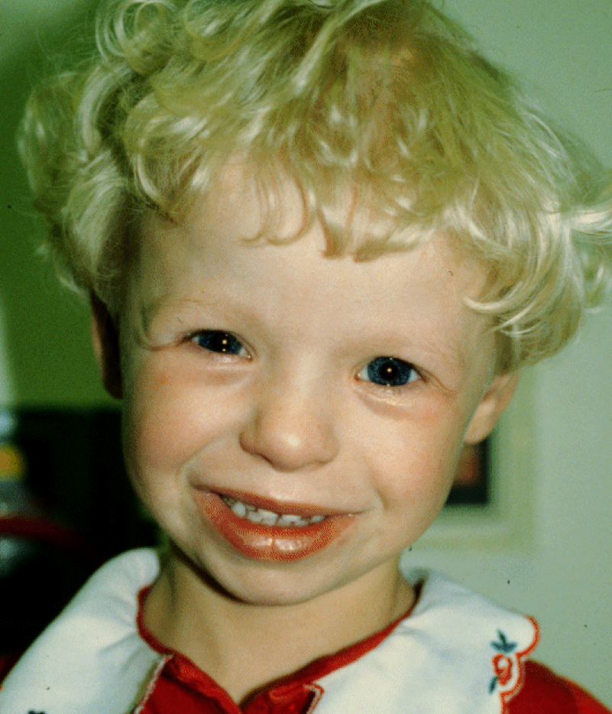
[Picture from http://medgen.genetics.utah.edu/photographs/pages/williams.htm]

- What is the diagnosis?

- What is the typical cardiac lesion associated with this condition?

- Name another likely cause for this child’s hypertension.

- How is the disorder diagnosed (what test would you order)?

- Which electrolyte in this patient is most likely to be abnormal and should be checked?

Answer to Genetic Quiz – Week 29

- The diagnosis is Williams syndrome.

- The typical cardiac lesion associated with this disorder is supravalvular aortic stenosis, although peripheral pulmonic stenosis, pulmonic valve stenosis, ASD and VSD are also seen.

- Another likely reason for the hypertension is a renal abnormality, typically renal artery stenosis. Other renal abnormalities included ectopic kidney, nephrocalcinosis, absent kidney, or asymmetric kidney size.

- This is a microdeletion syndrome, which can be detected on a chromosome analysis if deletion is large, but usually requires FISH (Fluorescent in situ hybridization) to detect.

- Hypercalcemia can occur in 15%-50% of patients. Therefore, serum calcium and urine spot calcium/creatinine ratio should be checked.

Reference: CA Morris. Williams Syndrome. in Pagon RA, Adam MP, Ardinger HH, et al., editors. GeneReviews® [Internet]. Seattle (WA): University of Washington, Seattle; 1993-2017.

Genetic Quiz – Week 30

A one year girl is noted to have a marked streaks and whorls of hyperpigmentation over her trunk, arms, and legs. The mother is present, but is of the limited intelligence, so the father provides the history. The skin abnormalities were not present at birth, but developed within the first few weeks of life. They began as lines of blisters which then became more wart-like in appearance – when those resolved, the affected areas became darkened in color. The lesions are pictured below.

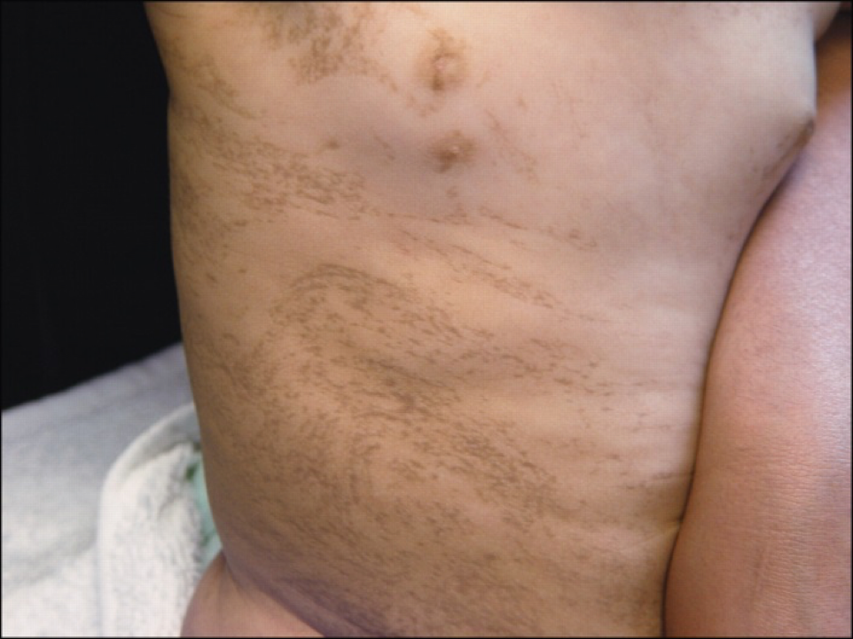
[Picture from Pediatrics in Review (2007) 28:11
http://pedsinreview.aappublications.org/content/28/11/429]

Additional family history reveals that the mother has similar lesions on her trunk and extremities. In addition, she has dental abnormalities (pictured below). This couple has had two pregnancy losses prior to this child’s birth.

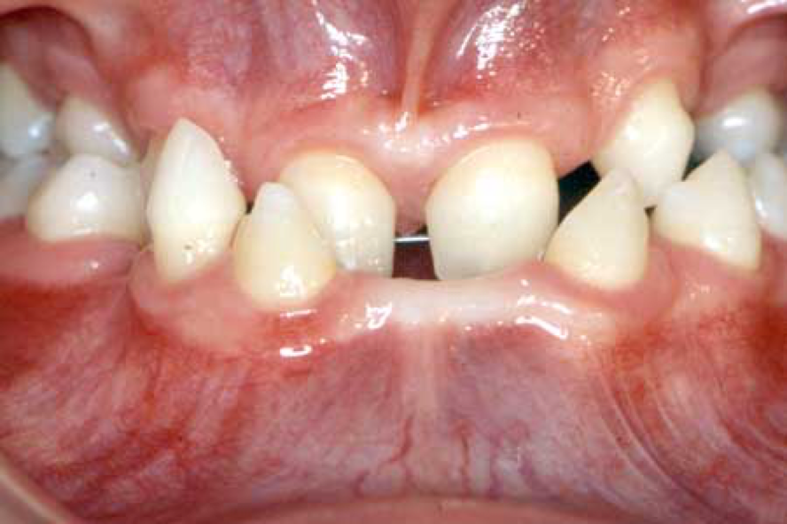
[Picture from http://www.dentaloracle.org/vip/hypodontia/pictures/H118.jpg]

- What is the diagnosis?

- How is it inherited?

- What is the significance of the prior pregnancy losses?

- Besides involvement of the skin and teeth, name two other systems involved in this disorder.
Answer to Genetic Quiz – Week 30

- This disorder is incontinentia pigmenti. It typically follows a four stage process –
  - Inflammatory stage when there are very tense vesicles (may be in the first few weeks of life)
  - Verrucous stage – the areas develop verrucous plaques, may or may not be associated with bullae – after the first few weeks of life.
  - Pigmentary stage – the area develops swirled or streaky hyperpigmentation, generally 2nd-6th months of life – pigmentation may persist.
  - Scarring stage – the areas become hypopigmented, and lose the sweat glands and hair in those distributions.

- It is inherited as an X-linked dominant.

- X-linked dominant disorders may be lethal in males, and the losses may represent affected male fetuses.

- Neurologic – mental retardation, seizure, hydrocephalus
Ocular – microphthalmos, strabismus, cataracts, blindness, optic atrophy, retinal changes
Skeletal – hemivertebrae, kyphoscoliosis, extra rib, syndactyly, limb shortening

Reference: AE Scheuerle, MV Ursin. Incontinentia Pigmenti. in Pagon RA, Adam MP, Ardinger HH, et al., editors. GeneReviews® [Internet]. Seattle (WA): University of Washington, Seattle; 1993-2017.

Genetic Quiz – Week 31

A two weeks old, full term male infant is brought in for evaluation of failure to thrive and dysmorphic features. There are two older, healthy children in the family and the parents are unrelated. On physical examination, the baby is noted to have microcephaly, marked bilateral ptosis with epicanthal folds, an upturned nose, and low set ears. There is a single transverse palmar crease on the right hand, and there is syndactyly of the second and third toes on each foot. There is a mild hypospadias, and the testicles are not palpated in the scrotum. Another child with this condition is pictured below:

[Picture from http://www.marmaramedicaljournal.org/text.php3?id=480]

- What is the diagnosis?

- What is the biochemical test used to confirm the diagnosis?

- What is the risk for each of his healthy siblings to be a carrier for this disorder?

Answer to Genetic Quiz – Week 31

- The diagnosis is Smith-Lemli-Opitz (SLO) syndrome.

- This disorder is caused by a biochemical defect in cholesterol biosynthesis. The specific compound which is elevated in this condition (and serves as a diagnostic indicator) is 7-dehydrocholesterol.

- The chance for healthy sibling to be a carrier is 2/3. While it may be tempting to give 1/2 or 50% as the answer, we can make a more accurate estimation of risk. Of the four possible outcomes of pregnancy to a couple at risk for genetic disorder, one is affected, one unaffected and two are carriers. In this case, we know the siblings are unaffected, eliminating one of the possibilities. Of the remaining three, two are carriers and one is unaffected – so the chance would be 2 out of 3 or 2/3.

Reference: MJM Nowaczyk. Smith-Lemli-Opitz Syndrome. in Pagon RA, Adam MP, Ardinger HH, et al., editors. GeneReviews® [Internet]. Seattle (WA): University of Washington, Seattle; 1993-2017.

Genetic Quiz – Week 32

An eight years old boy is brought in by his mother for evaluation of behavioral change and developmental regression. He has been diagnosed with attention-deficit hyperactivity and followed up with pediatrician for two years. His grade drops and he is repeating grade 1. His mother complains that he cannot follow simple two-steps commands like “take a bath and dress properly”. She had to tell him step by step. Physical examination reveals a hyperactive boy running around physical exam room. He is alert but rarely co-operative. No dysmorphic features was found except for skin hyperpigmentation.

He was AGA, full term infant born from uneventful pregnancy. He had never experienced serious illnesses since birth. His vaccination is up-to-date. He has a three years old brother that is reported to be normal development by his mother. You order the brain MRI and it shows symmetric enhanced T2 signal in the parieto-occipital region (pictured below).

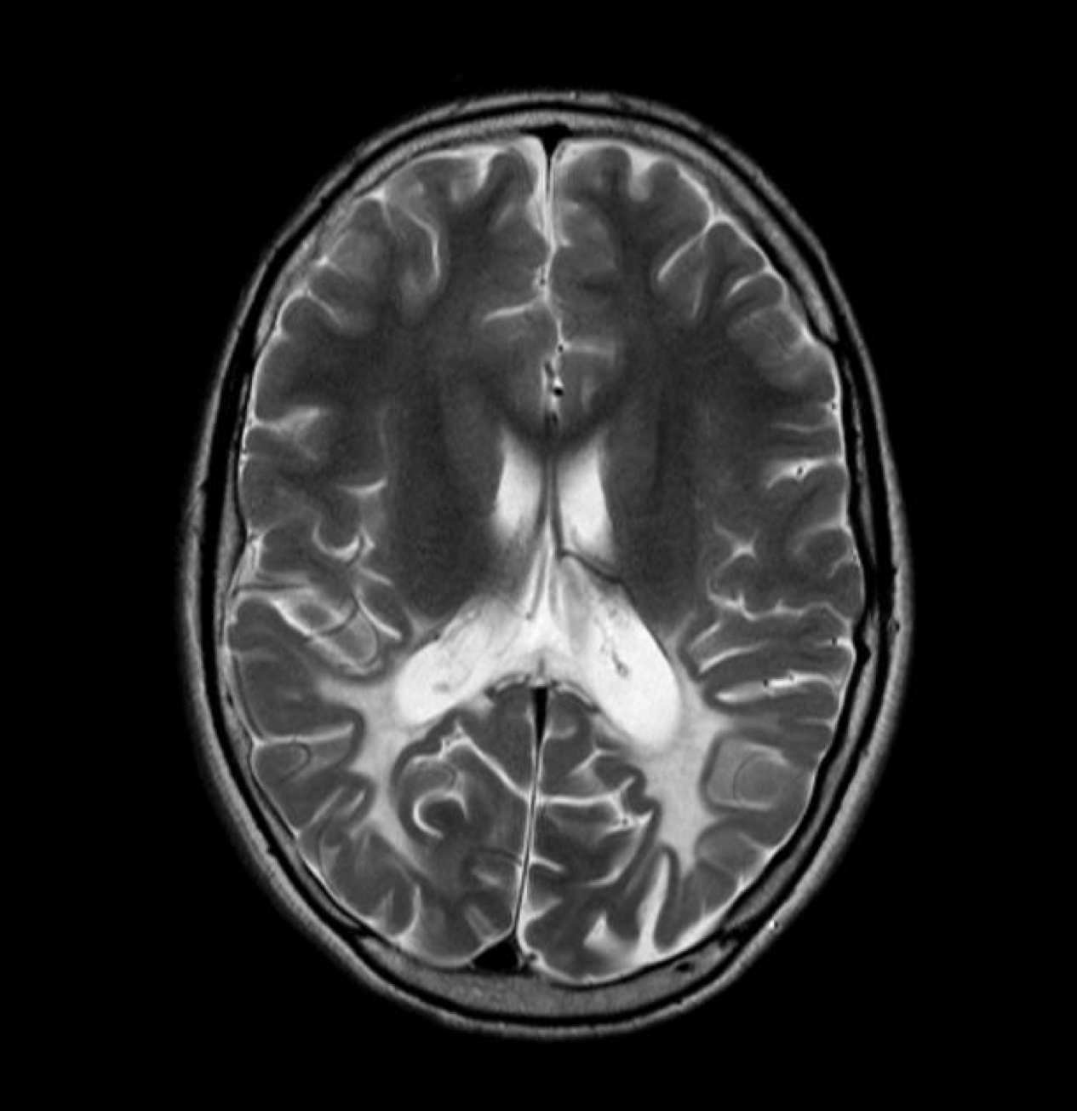
[Picture from https://radiopaedia.org/articles/adrenoleukodystrophy]

- What is the most likely diagnosis?

- What is the pathway that the disease-associated gene involved?

- What is the inheritance?

- What test should be done with the patient’s brother, if any?

Answer to Genetic Quiz – Week 32

- The most likely diagnosis is X-linked Adrenoleukodystrophy (X-ALD).

- The ABCD1 gene is involved in very long chain fatty acid oxidation in peroxisome.

- The mode of inheritance is X-linked recessive.

- The genetic testing of ABCD1 gene in the male sibling of the patient should be done if the mother is a carrier for ABCD1 mutation. Because the symptom of X-ALD is varied among patients with no established genotype-phenotype correlation, male individuals that have ABCD1 mutation may present with severe childhood cerebral form (as in this patient) or isolated Addison’s disease, or even asymptomatic! So aymptomatic male sibling that was proven to have mutation needs to be screened for brain change (by MRI surveillance). If any change in MRI is detected without the presence of significant neuropsychological findings, bone marrow transplantation is a choice of treatment. The sibling also needs to be screened for corticosteroid hormone level, and supplement of hormone if that patient is found to have Addison’s disease.

Reference: SJ Steinberg, AB Moser, GV Raymond. X-Linked Adrenoleukodystrophy. in Pagon RA, Adam MP, Ardinger HH, et al., editors. GeneReviews® [Internet]. Seattle (WA): University of Washington, Seattle; 1993-2017.

