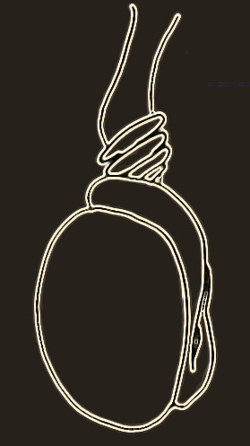Pa

**Testicular Torsion**

**Clinical Pathway**

**Goal**: ED to OR in < 2.5 hours

Male patient, scrotal/testicular pain for <24 hours.

* ***Call results to Urology On***

***Call and ED Attending***

* ***Patients in radiology may go***

***directly to surgical***

***preparation – confirm with***

***Urology resident***

**Contact**: Urology (Pager 50022)

ED Attending (x8198)