RETROFILL BLADDER KIT

Items required from sonographer:
Saline bag (500mL) Plastic tubing Blue catheter adapter Hemostat
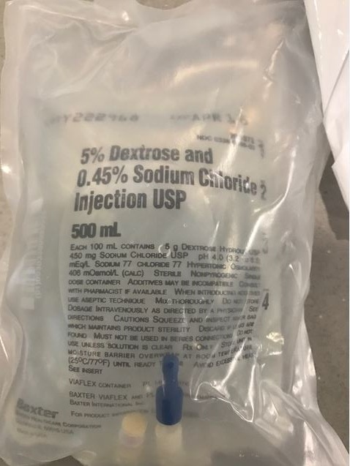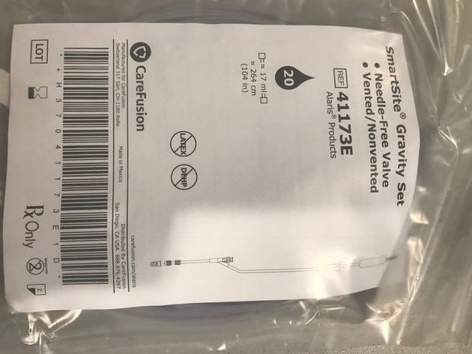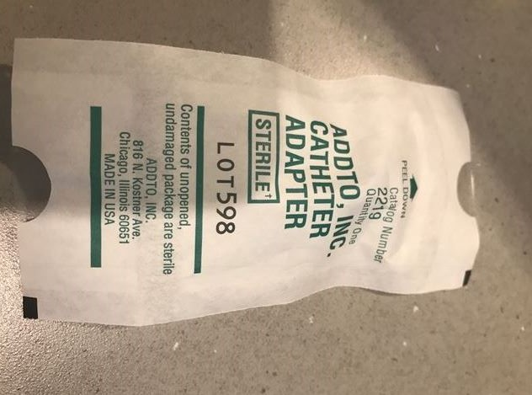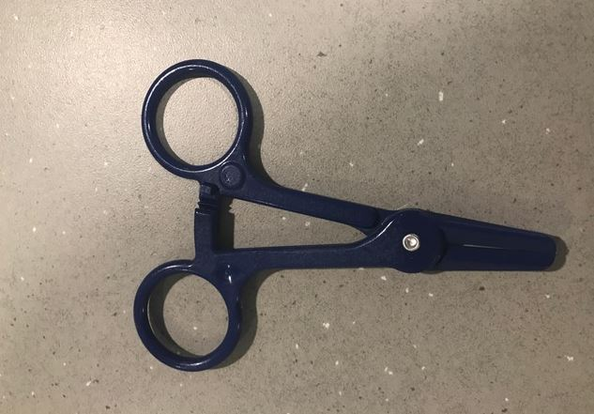

Required from ED:
Foley cath placement

STEP BY STEP PROCESS:
- Open plastic tubing
- Uncap clear plastic tip from tubing packet
- Remove blue rubber appendage on saline bag and insert plastic tubing tip
- Attach blue cath adapter to plastic tubing and twist
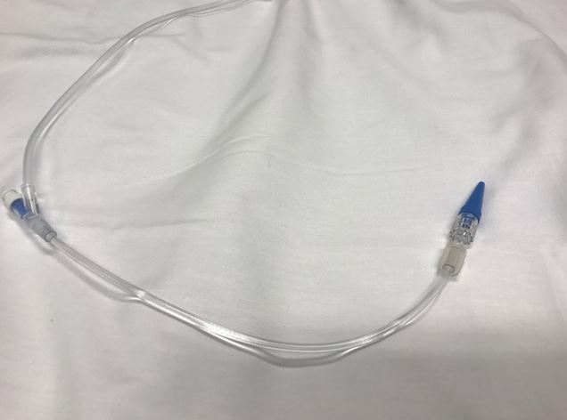
- Hemostat foley
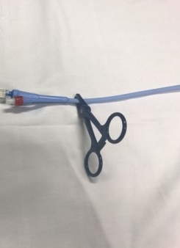

- Unhook urine bag and insert blue cath adapter into foley (cover the entire blue cath adapter for best fit)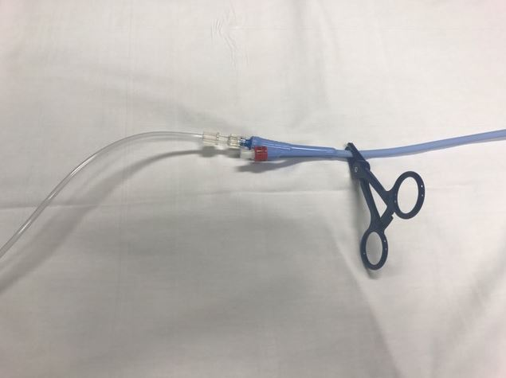
- Hang saline bag on either stretcher pole or mobile IV pole
- Unclamp hemostat to allow retro bladder fill
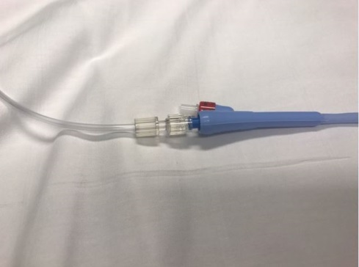
- Image bladder to ensure adequate filling (and avoid overfilling)
- When adequate volume is obtained, hemostat tubing to discontinue saline flow
- Perform exam, alert RN when US is complete

HELPFUL TIPS:
If saline is not flowing, check plastic rolling mechanism on tubing to ensure open path of flow.
To STOP saline flow, adjust rolling mechanism or hemostat plastic tubing.
