CHILDREN’S NATIONAL MEDICAL CENTER
DEPARTMENT OF RADIOLOGY
ULTRASOUND PROTOCOL
______________________________________________________________________

Issue Date: 05/02/2014 Policy: Lower Extremity VENOUS DOPPLER
Last Revision Date: 01/13/2017 Approved by:

- Indications for lower extremity venous Doppler include but are not limited to:
- Evaluation for venous obstruction, thromboembolic disease,
- Evaluate for venous insufficiency, varicosities, or reflux.
- Assessment for dialysis or graft access.
- Venous mapping prior to surgery or graft placement.

B. Protocol:
Confirm patient identity using standard hospital protocol (2 patient identifiers).
Verify physician order.
Wash hands prior to patient contact, in addition to utilizing standard & or isolation precautions as appropriate.

Venous Thromboembolic Disease: Lower Extremity

1. Technique
a. Compression (when possible): The fullest visualized extent of the common femoral, femoral and popliteal veins must be imaged using an optimal gray scale compression technique. The popliteal vein is examined distally to the tibioperoneal trunk. Venous compression is applied in the transverse (short axis) plane.
b. Color or spectral Doppler evaluation can be used to support the presence or absence of an abnormality. All spectral Doppler waveforms should be obtained from the long axis.
2. Recording
a. For normal examinations, at a minimum:
i. Gray scale images should be recorded without and with compression (when possible) at each of the following levels, at a minimum:
a. Iliac vein;
b. Common femoral vein;
c. Junction of the common femoral vein with the great saphenous vein;
d. Proximal deep femoral vein separately or along with the proximal femoral vein;
e. Proximal femoral vein;
f. Mid femoral vein;
g. Distal femoral vein;
h. Popliteal vein;

ii. Color and Spectral Doppler waveforms from the long axis should be recorded at each of the following levels, at a minimum:
- Iliac vein;
- Common femoral / Saphenofemoral junction
- Proximal, mid, and distal femoral vein
- Popliteal vein

iii. Calf veins (when possible) - Compression and color Doppler should be used to examine the paired posterior tibial and peroneal veins in cooperative patients (if under the age of 5), and all patients over age 5.

b. Abnormal symptoms or findings generally require additional images to document the complete extent of the abnormalities:
i. Symptomatic areas such as the calf generally require additional evaluation and additional images if the cause of the symptoms is not readily elucidated by the standard examination.
ii. The extent and location of sites where the veins fail to compress completely should be clearly recorded and generally require additional images. Long-axis views without compression may be helpful to characterize the abnormal vein.

c. The patient presentation, clinical indication, or clinical management pathways may require protocol adjustments such as more detailed evaluation of the superficial venous system, evaluation of the deep calf veins, or a bilateral study.
d. Other vascular and nonvascular abnormalities, if found, should be recorded but may require additional imaging for diagnosis or further characterization. Anatomic variations such as duplications should be noted.

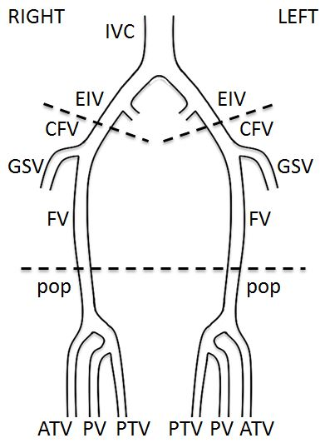

Reference: American Institute of Ultrasound in Medicine. AIUM-ACR-SRU Practice Parameter for the Performance of Peripheral Venous Ultrasound Examinations. 2015. http://www.aium.org/resources/guidelines/peripheralVenous.pdf Accessed October 29th, 2016.

