Fronto-Occipital Ratio
FOR = (A+B)/2C and is calculated using the labeled measurements.
- A = Widest distance across frontal horns
- B = Widest distance across occipital horns
- C = Widest biparietal diameter
Calculate FOR on multiple slices, and use maximal FOR for clinical decision making.
Normative Absolute Values
- Normal = 0.4 Mild HC = 0.55
- Moderate HC = 0.60 Severe HC = 0.7
- Good inter-rater reliability (> 0.9)
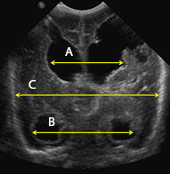
Frontal and Temporal Horn Ratio (FTHR)
FTHR = A+D/2E
- A = Widest distance across frontal horns
- D = Widest difference across temporal horns
- E = Broadest skull diameter at level of foramen Monro
Correlates highly with volumetric determinations
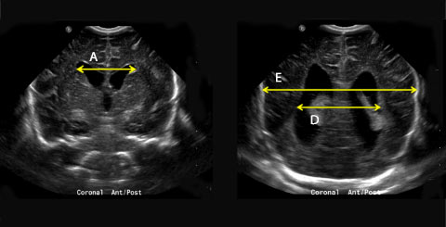
Kulkarni AV, et al. Measurement of ventricular size: reliability of the frontal and occipital horn ratio compared to subjective assessment. Pediatr Neurosurg. 1999;31(2):65–70.
O'Hayon BB, et al. Frontal and occipital horn ratio: A linear estimate of ventricular size for multiple imaging modalities in pediatric hydrocephalus. Pediatr Neurosurg. 1998;29(5):245–249.
Antes S, et al. The frontal and temporal horn ratio to assess dimension of paediatric hydrocephalus: a comparative volumetric study. Acta Neurochir Suppl. 2013;118:211–214. doi:10.1007/978-3-7091-1434-6_39.

CHOP protocol - Consider Reservoir if the Neonate Meets the Following Criteria
Birth Weight | < 1500 g  > 1500 g consider VP shunt
Intraventricular Hemorrhage | Grade III or IV
Life Expectancy | > 72 hours
FOR or FTHR | ≥ 0.55 (moderate hydrocephalus) or an increase in FOR of 0.1

PLUS at least 2 of the following:
Bradycardia | ≥ 3 episodes requiring intervention or lasting more than 30 seconds per 24 hours not explained by other cause
Split Sutures | > 2 mm (roughly a fingertip) measured 1 cm from the fontanelle
Bulging Fontanelle | Above the level of the bone while calm, sitting

Decision to Convert Reservoir
Observe | FOR is not ≥ 0.55 and  No persistent tapping by term date
Continue Taps | FOR ≥ 0.55  Persistent tapping by term date  Extra-choroidal IVH  Current weight is < 1500 g  Abdomen not usable
Surgeon Preference | FOR ≥ 0.55  Persistent tapping by term date  Extra-choroidal IVH  Current weight is 1500-2000 g  Abdomen usable
Shunt/ETV | FOR ≥ 0.55  Persistent tapping by term date  Extra-choroidal IVH  Current weight ≥ 2000 g  Abdomen usable  When considering conversion, patient should get MRI so an Endoscopic Third Ventriculostomy (ETV) with CPC coagulation can be considered

