CHILDREN’S NATIONAL MEDICAL CENTER
DEPARTMENT OF RADIOLOGY
ULTRASOUND PROTOCOL
______________________________________________________________________
Issue Date: 05/02/2014 Policy: Upper Extremity VENOUS DOPPLER
Last Revision Date: 01/04/2017 Approved by:
- Indications for upper extremity venous Doppler include but are not limited to:
- Evaluation for venous obstruction, thromboembolic disease.
- Evaluate for venous insufficiency, varicosities, or reflux.
- Assessment for dialysis or graft access.
- Venous mapping prior to surgery or graft placement.

- Technique:
a. Upper extremity duplex evaluation consists of gray scale and color and spectral Doppler assessment of all the accessible portions of the internal jugular, subclavian, axillary, and innominate veins, as well as compression (when possible) gray scale ultrasound of the brachial, basilic, and cephalic veins in the upper arm to the elbow. All accessible veins should be scanned using optimal gray scale and Doppler techniques as well as appropriate positioning. Venous compression is applied to accessible veins in the transverse plane with adequate pressure on the skin to completely obliterate the normal vein lumen. Supine position, if possible, is preferred. Symmetrical posture to prevent false asymmetry, if possible, is preferred.
b. Symptomatic areas, such as the forearm, may require additional evaluation if the cause of the symptoms is not already elucidated by the standard examination.

- Protocol:
  - Confirm patient identity using standard hospital protocol (2 patient identifiers).
  - Verify physician order.
  - Wash hands prior to patient contact, utilizing standard & or isolation precautions as appropriate.

Venous Thromboembolic Disease: Upper Extremity
(Bilateral, Right, or Left)
- Jugular v. – split screen grayscale without and with compression (when possible)
- Jugular v. – color and spectral Doppler
- Brachiocephalic v. – color and spectral Doppler
- Brachiocephalic at junction with jugular and subclavian color and spectral Doppler
- Subclavian v. – split screen without and with compression (Valsalva or “sniff” works)
- Subclavian v. – color and spectral Doppler
- Axillary v. transverse – split screen without and with compression
- Axillary v. longitudinal – color and spectral Doppler
- Brachial v. transverse – split screen without and with compression
- Brachial v. longitudinal – color and spectral Doppler
- Basilic v. transverse – split screen without and with compression
- Basilic v. longitudinal – color and spectral Doppler
- Cephalic v. transverse – split screen without and with compression
- Cephalic v. longitudinal – color Doppler

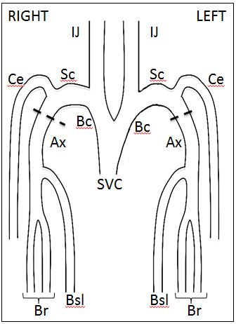

Reference: American Institute of Ultrasound in Medicine. AIUM-ACR-SRU Practice Parameter for the Performance of Peripheral Venous Ultrasound Examinations. 2015. http://www.aium.org/resources/guidelines/peripheralVenous.pdf Accessed October 29th, 2016.

